REG NO: 21RP00478

NAMES: EMMANUEL Nzaramyimana

DEPERTMENT: ELECTRICAL AND ELECTRONIC ENGINEERING

OPTION: ELECTRICAL AUTOMATION TECHNOLOGY

**SECURITY SYSTEM USING ULTRASONIC SENSOR**

Motion detection has become one of the great areas of research in the world. Many activities are carried out in the presence of motion. One of the research focus has been the use of Arduino Uno microcontroller, Ultrasonic sensor, passive infrared sensor and many others to sense and measure distances.

The goal is to measure and monitor human activity remotely, and using less manpower as much as possible. This study aimed at designing a sensor that can easily measure how far the object is, monitor change of distances as the object approach.

The hardware utilized included the Arduino Uno on a bread board interfaced with LEDs, Buzzer and Ultrasonic sensor. The program to run the circuit was developed using Arduino IDE and stored at the memory of the Arduino

microcontroller.

**PURPOSE OF PROJECT**

As the name indicates, ultrasonic sensors measure distance by using ultrasonic waves. The sensor head emits an ultrasonic wave and receives the wave reflected back from the target. Ultrasonic Sensors measure the distance to the target by measuring the time between the emission and reception and then other leds bright and even buzzer give us sound. So, this project can be used in industry, military application, home application and other difference field to avoid theft.

**COMPONENT NEEDED TO COMPLET MY PROJECT**

1. **Arduino uno:** The Arduino Uno is an open-source microcontroller board based on the Microchip ATmega328P microcontroller .The board is equipped with sets of digital and analog input/output pins that may be interfaced to various expansion boards and other circuits**.**

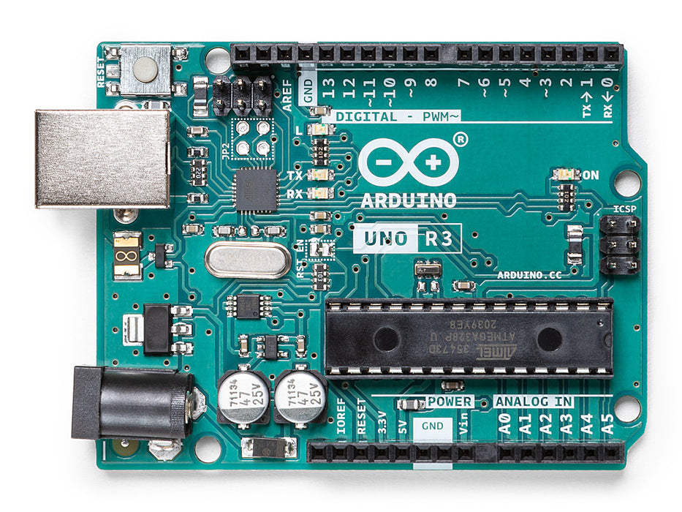

1. **ULTRASONIC SENSOR**: is an electronic device that measures the distance of a target object by emitting ultrasonic sound waves, and converts the reflected .

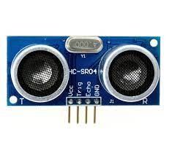

1. **LIGHT EMITTING DIODE(LED):** is **a semiconductor device that emits light when an electric current flows through it**. B  light-emitting diode (LED) is **a semiconductor device that emits light when an electric current flows through it.**

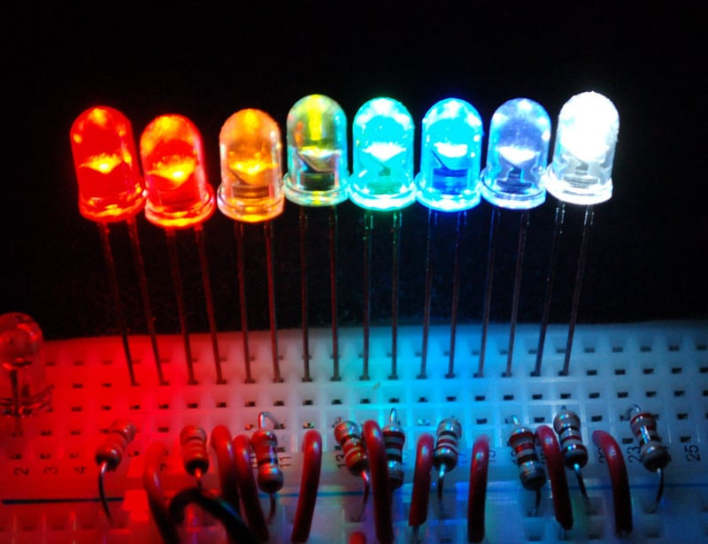

1. **RESISTOR:** is a passive two-terminal electrical component that implements electrical resistance as a circuit element. In electronic circuits, resistors are used to reduce current flow, adjust signal levels, to divide voltages, bias active elements, and terminate transmission lines, among other uses.

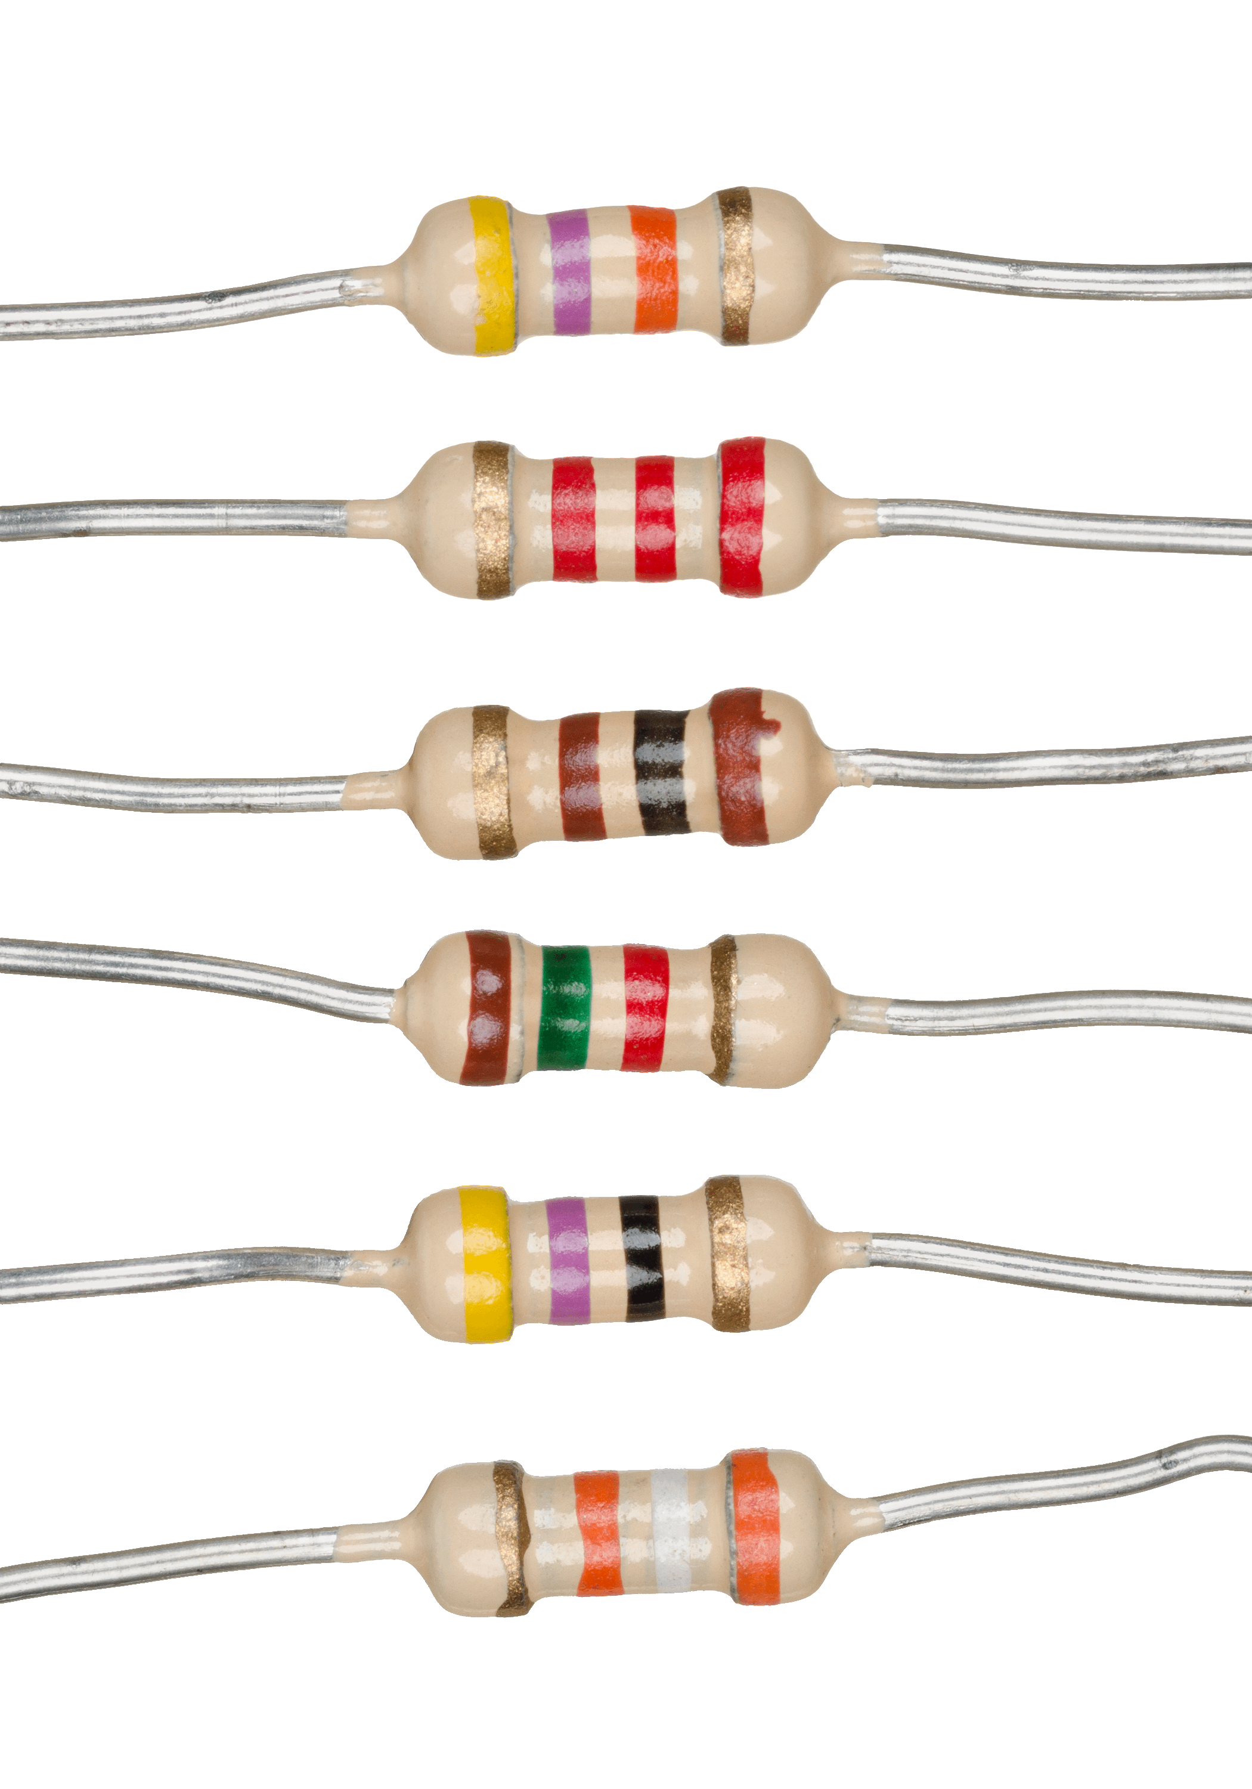

1. breadboard, solderless breadboard, or protoboard is a construction base used to build semi-permanent prototypes of electronic circuits.

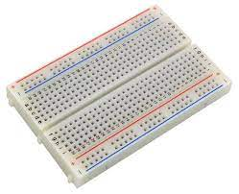

1. **JUMPER WIRE.** is an electrical wire, or group of them in a cable, with a connector or pin at each end, which is normally used to interconnect the components of a breadboard or other prototype or test circuit.
2. 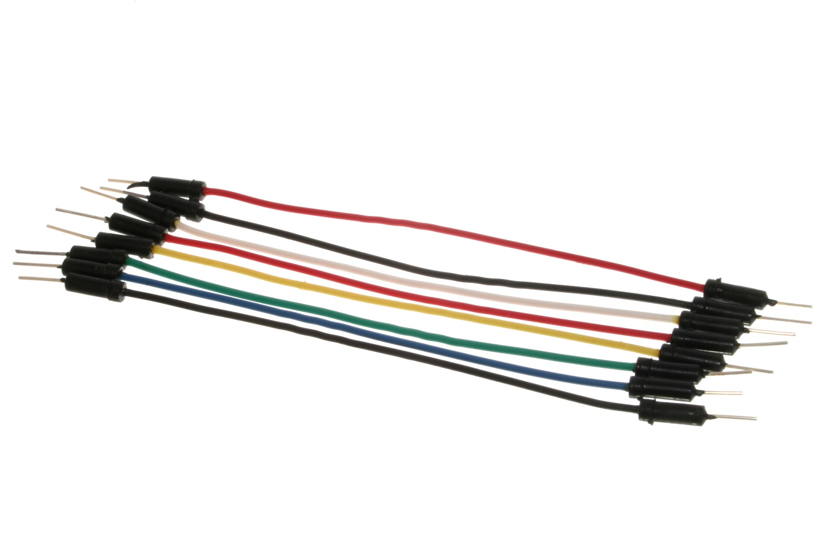  **BUZZER.** is an audio signaling device, which may be mechanical, electromechanical, or piezoelectric.

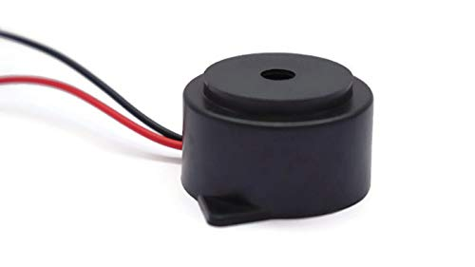

**CIRCUIT DIAGRAM**

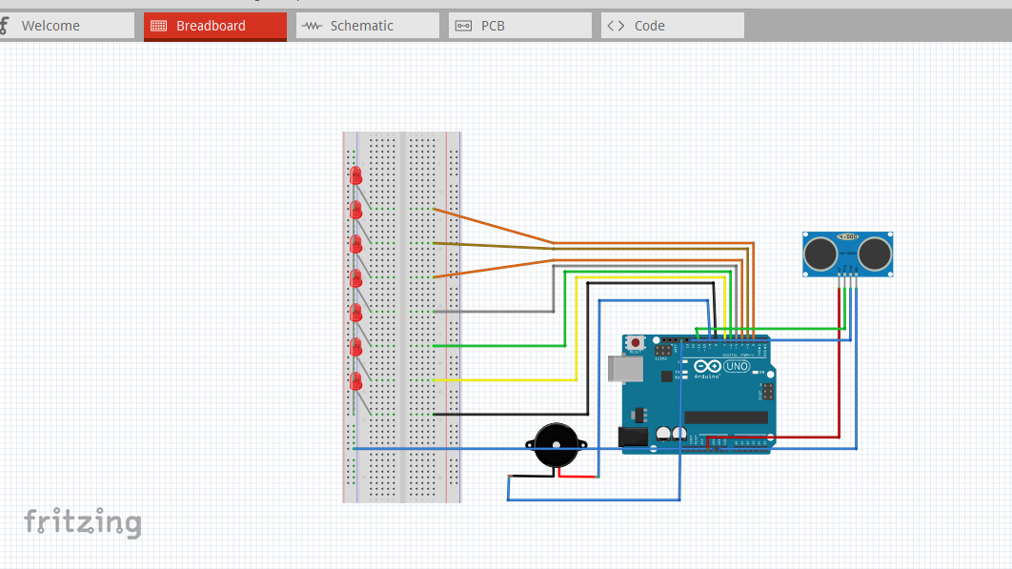

**CODES**

**const int trig = 11;**

**const int echo = 12;**

**const int LED1 = 2;**

**const int LED2 = 3;**

**const int LED3 = 4;**

**const int LED4 = 5;**

**const int LED5 = 6;**

**const int LED6 = 7;**

**const int LED7 = 8;**

**const buzzer = 9;**

**int duration = 0;**

**int distance = 0;**

**void setup()**

**{**

**pinMode(trig , OUTPUT);**

**pinMode(echo , INPUT);**

**pinMode(LED1 , OUTPUT);**

**pinMode(LED2 , OUTPUT);**

**pinMode(LED3 , OUTPUT);**

**pinMode(LED4 , OUTPUT);**

**pinMode(LED5 , OUTPUT);**

**pinMode(LED6 , OUTPUT);**

**pinMode(LED7 , OUTPUT);**

**pinMODE(buzzer , OUTPUT);**

**Serial.begin(9600);**

**}**

**void loop()**

**{**

**digitalWrite(trig , HIGH);**

**delayMicroseconds(1000);**

**digitalWrite(trig , LOW);**

**duration = pulseIn(echo , HIGH);**

**distance = (duration/2) / 28.5 ;**

**Serial.println(distance);**

**if ( distance <= 5 )**

**{**

**digitalWrite(buzzer, HIGH);**

**}**

**else**

**{**

**digitalWrite(buzzer, LOW);**

**}**

**if ( distance <= 5 )**

**{**

**digitalWrite(LED1, HIGH);**

**}**

**else**

**{**

**digitalWrite(LED1, LOW);**

**}**

**if ( distance <= 7 )**

**{**

**digitalWrite(LED2, HIGH);**

**}**

**else**

**{**

**digitalWrite(LED2, LOW);**

**}**

**if ( distance <= 10 )**

**{**

**digitalWrite(LED3, HIGH);**

**}**

**else**

**{**

**digitalWrite(LED3, LOW);**

**}**

**if ( distance <= 15 )**

**{**

**digitalWrite(LED4, HIGH);**

**}**

**else**

**{**

**digitalWrite(LED4, LOW);**

**}**

**if ( distance <= 17 )**

**{**

**digitalWrite(LED5, HIGH);**

**}**

**else**

**{**

**digitalWrite(LED5, LOW);**

**}**

**if ( distance <= 20 )**

**{**

**digitalWrite(LED6, HIGH);**

**}**

**else**

**{**

**digitalWrite(LED6, LOW);**

**}**

**if ( distance <= 25 )**

**{**

**digitalWrite(LED7, HIGH);**

**}**

**else**

**{**

**digitalWrite(LED7, LOW);**

**}**

**}**